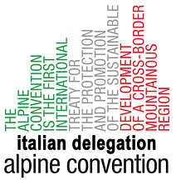

REGISTRATION FORM
International conference, September the 7th 2015, Venice
10.00-13.30
Aquae EXPO 2015 – Marghera-Venice, Ferraris street 5

FLOOD RISK MANAGEMENT PLANS: INTERNATIONAL EXPERIENCE IN COMPARISON

Send to: segreteria@adbve.it
DEADLINE FOR REGISTRATION 10/8/2015

Name |  |  |  | Surname
Administration
Email
City - Nation
Function – Area
Note for partecipants:
The organising secretary is managed by AAWA
The conference is free. Registration is requested by email to: segreteria@adbve.it.
The conference room is inside the exhibition hall of EXPO VENICE, official reseller of MILAN 2015. The train station of Porto Marghera is got in a few minutes. Hotel suggestions can be found on the website http://www.bookingvenice.eu or
also by email: info@bookingvenice.eu

